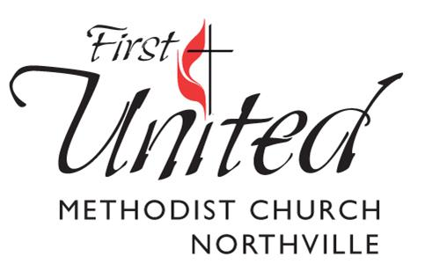
WEDDING REQUEST FORM

Congratulations on your engagement! To request a wedding date at First United Methodist Church of Northville, please fill out the form below. Note: No wedding date is officially reserved until you have met with one of our pastors.

REQUESTED DATE OF WEDDING: ____________________ Time of Wedding:_____________________

Alternative Date(s) of Wedding: _______________________________________________________________

COUPLE’S INFORMATION

Full Name: ________________________________________________Date of Birth:_____________

Phone:______________________________Email:_____________________________________ Member: Y/N

Mailing Address:___________________________________________________________________________

_________________________________________________________________________________________

Full Name:_______________________________________________ Date of Birth:______________

Phone:______________________________Email:_____________________________________ Member: Y/N

Mailing Address:___________________________________________________________________________

__________________________________________________________________________________________

Please return to Denise Orth-Berg by email dorthberg@fumcnorthville.org or mail to address below.

cc: Rev. Marsha M. Woolley
Rev. Sarah Wheatley
Denise Orth-Berg

777 W. Eight Mile Rd., Northville, MI 48167 ~ Phone: 248-349-1144 ~ www.fumcnorthville.org

